DESCRIPTIVE ANALYTICS
Automobile Service Network
Case Study Document and Detailed Solution
Analysis of 2,000 historical service records from calendar year 2025
2,000  Service records | 19  Dataset fields | 12 months  Reporting period
4 cities  Network coverage | 10 centers  Operational units | Case + solution  Trainer-ready format
Training Resource
Synthetic data for classroom demonstration; no real customer information is included.

How to Use This Document

Part A - Learner Case Study
Contains the business scenario, data dictionary, required analysis questions and expected deliverables. It can be shared with participants before the solution is discussed.

Part B - Detailed Instructor Solution
Contains data-quality checks, exact KPI calculations, analysis tables, charts, business interpretations, recommended actions and a complete Python solution.

Contents
Section | Topic
Part A | Learner Case Study
1 | Background and business problem
2 | Dataset overview and data dictionary
3 | Learner analysis tasks and deliverables
Part B | Detailed solution
4 | Data preparation and validation
5 | KPI calculations
6 | Monthly, city and service analysis
7 | Customer experience and repeat visits
8 | Management findings and recommendations
9 | Complete Python solution
10 | Trainer discussion guide and assessment rubric
Recommended duration: 60-90 minutes for individual analysis, followed by 30-45 minutes for solution review and management discussion.

PART A - LEARNER CASE STUDY

1. Background and Business Problem

1.1 Business scenario
A multi-city automobile service network operates 10 service centers across Pune, Mumbai, Nashik and Nagpur. During 2025, the network completed 2,000 service jobs covering inspections, scheduled maintenance, repairs, emergency work and recalls.
Management receives operational data from each service center, but it does not yet have one consolidated view of what happened during the year. Before making staffing, inventory and service-quality decisions, management wants a descriptive analytics report that summarizes performance and identifies areas requiring further investigation.
Central business question
What happened across the service network during 2025 in terms of service volume, revenue, turnaround time, customer satisfaction and repeat visits?

1.2 Business objectives
- Measure total service volume and annual revenue.
- Identify the strongest and weakest months by revenue, workload and customer rating.
- Compare city and service-center performance.
- Understand the revenue and operational effort associated with each service type.
- Identify complaint categories with long turnaround times or high repeat-visit rates.
- Prepare a management summary supported by tables and charts.

1.3 Analytics boundary
This is a descriptive analytics case. The analysis summarizes historical records and highlights patterns. It does not prove why a result occurred, predict future outcomes or prescribe an optimized decision without further analysis.
Question | Application in this case
What? | Summarize historical service activity and customer outcomes.
Why? | Understand past performance, compare units and detect operational signals.
Who? | Business analysts, service managers, operations heads and reporting teams.
When? | During monthly, quarterly and annual performance reviews.
Where? | Across service centers, cities, service types and complaint categories.
How? | Clean, group and summarize data using counts, totals, averages, percentages, tables and charts.

2. Dataset Overview and Data Dictionary
Dataset file
automobile_service_descriptive_analytics_2000_records.csv contains 2,000 rows and 19 columns. Each row represents one completed service job.

Dataset aspect | Details
Observation unit | One completed automobile service job
Period | 1 January 2025 to 31 December 2025
Records | 2,000
Cities | Pune, Mumbai, Nashik and Nagpur
Service centers | 10
Target report type | Descriptive analytics management report
Field | Type | Meaning | Example
service_id | Text | Unique service-job identifier | SRV-00001
service_date | Date | Date on which the job was completed | 2025-10-21
month | Text | Abbreviated reporting month | Oct
city | Text | City of the service center | Nagpur
service_center | Text | Name of the operating center | Hingna Service Hub
vehicle_model | Text | Vehicle model serviced | Virtus
vehicle_age_years | Decimal | Vehicle age in years | 4.6
mileage_km | Integer | Odometer reading in kilometres | 60,204
service_type | Text | Type of service job | Repair
complaint_category | Text | Primary customer complaint | Engine
warranty_status | Text | Warranty coverage status | Under Warranty
parts_cost_inr | Integer | Parts cost charged or recognized | 4,600
labor_cost_inr | Integer | Labour charge | 2,300
total_bill_inr | Integer | Total bill amount | 7,420
turnaround_hours | Decimal | Hours from job intake to completion | 8.5
customer_rating | Decimal | Customer rating from 1 to 5 | 4.6
repeat_visit_30d | Text | Whether customer returned within 30 days | Yes/No
technician_experience_years | Integer | Technician experience in years | 8
payment_mode | Text | Customer payment method | UPI
Sample record preview
ID | Date | City | Model | Service type | Bill (INR) | TAT (hrs) | Rating
SRV-00001 | 21-Oct-2025 | Nagpur | Virtus | Inspection | 1,850 | 1.9 | 4.9
SRV-00002 | 09-Oct-2025 | Nashik | Taigun | Scheduled Maintenance | 4,130 | 2.2 | 4.9
SRV-00003 | 20-Feb-2025 | Pune | Virtus | Inspection | 1,820 | 1.5 | 4.3
SRV-00004 | 16-Jun-2025 | Pune | Polo | Inspection | 3,340 | 5.3 | 4.3
SRV-00005 | 27-Jan-2025 | Pune | Virtus | Scheduled Maintenance | 3,460 | 6.8 | 4.8
SRV-00006 | 05-Jun-2025 | Pune | Virtus | Recall | 1,200 | 6.5 | 4.4

3. Learner Analysis Tasks and Deliverables
Role
You are the business analyst assigned to prepare the annual descriptive analytics report for the Head of Service Operations.

3.1 Task A - Data understanding and quality checks
- Confirm the number of rows and columns.
- Check for missing values, duplicated rows and duplicated service IDs.
- Confirm the minimum and maximum service dates.
- Review the unique categories for city, service type, complaint category, warranty status and repeat_visit_30d.

3.2 Task B - Network-level KPIs
- Calculate total service jobs and total revenue.
- Calculate average and median bill amount.
- Calculate average and median turnaround time.
- Calculate average customer rating.
- Calculate the number and percentage of repeat visits within 30 days.

3.3 Task C - Monthly performance
- Create a monthly table with job count, total revenue, average bill, average turnaround time, average rating and repeat-visit rate.
- Identify the highest- and lowest-revenue months.
- Identify the month with the lowest average customer rating.
- Create a suitable monthly revenue chart and interpret the pattern.

3.4 Task D - City and service-center performance
- Compare cities by job count, total revenue, average bill, turnaround time and rating.
- Identify the highest-revenue city and calculate its contribution to total revenue.
- Identify the top five service centers by revenue.
- Explain why revenue should not be reviewed without workload and customer-service measures.

3.5 Task E - Service type and complaint analysis
- Compare service types by volume, revenue, average bill, turnaround time and repeat visits.
- Identify which service type generates the highest revenue and which takes the longest.
- Compare complaint categories and identify the highest repeat-visit rate.
- Suggest operational areas management should investigate. Do not claim causation from descriptive data alone.

3.6 Task F - Customer experience
- Create customer-rating groups: Below 4.0, 4.0-4.49 and 4.5-5.0.
- Compare repeat visits for warranty and out-of-warranty vehicles.
- Identify the top 5% of service jobs by turnaround time.
- Prepare three management actions based on the results.

3.7 Required deliverables
No. | Deliverable
1 | One-page executive summary
2 | KPI table with formulas and results
3 | Monthly, city, service-type and complaint analysis tables
4 | At least four charts
5 | Five key findings and three management recommendations
6 | Analysis file or Python notebook used to produce the results
Submission rule
Use descriptive language such as highest, lowest, average, percentage, increased, decreased or concentrated. Statements about causes must be presented as questions for further investigation, not as proven explanations.

PART B - DETAILED INSTRUCTOR SOLUTION

4. Data Preparation and Validation

4.1 Import and inspect the data
import pandas as pd
file_name = "automobile_service_descriptive_analytics_2000_records.csv"
data = pd.read_csv(file_name, parse_dates=["service_date"])
print(data.shape)
print(data.head())
print(data.info())

Validation check | Result | Interpretation
Rows | 2,000 | Matches the case-study scope
Columns | 19 | All expected variables are present
Missing values | 0 | No missing values detected
Duplicate rows | 0 | No duplicated full records
Duplicate service IDs | 0 | Each service ID is unique
Minimum service date | 01-Jan-2025 | Start of the reporting period
Maximum service date | 31-Dec-2025 | End of the reporting period
Validation conclusion
The dataset is complete and internally consistent for the intended descriptive analysis. Real projects would also check source-system definitions, billing rules, unusual outliers and whether every completed job was captured.

4.2 Prepare month order and derived fields
month_order = [
"Jan", "Feb", "Mar", "Apr", "May", "Jun",
"Jul", "Aug", "Sep", "Oct", "Nov", "Dec"
]
data["month"] = pd.Categorical(
data["month"], categories=month_order, ordered=True
)
data["repeat_flag"] = (data["repeat_visit_30d"] == "Yes").astype(int)
data["rating_group"] = pd.cut(
data["customer_rating"],
bins=[0, 3.99, 4.49, 5.0],
labels=["Below 4.0", "4.0-4.49", "4.5-5.0"],
include_lowest=True
)

5. Network-Level KPI Calculations
KPI | Formula | Result | Business meaning
Total jobs | COUNT(service_id) | 2,000 | Annual service workload
Total revenue | SUM(total_bill_inr) | INR 21,178,420 | Annual billed value
Average bill | Revenue / jobs | INR 10,589.21 | Mean value per job
Median bill | 50th percentile of bill | INR 7,605 | Typical bill less affected by high bills
Average TAT | SUM(hours) / jobs | 10.29 hours | Mean completion time
Median TAT | 50th percentile of hours | 8.25 hours | Typical completion time
Average rating | SUM(ratings) / jobs | 4.45 / 5 | Overall satisfaction indicator
Repeat visits | Yes count / jobs x 100 | 134 (6.7%) | Potential service-quality signal
Worked calculation - average bill
Average bill = Total revenue / Total jobs
= INR 21,178,420 / 2,000
= INR 10,589.21

Worked calculation - repeat-visit rate
Repeat-visit rate = Repeat visits / Total jobs x 100
= 134 / 2,000 x 100
= 6.7%

Why report the median?
The average bill is INR 10,589 while the median is INR 7,605. The higher average indicates that expensive repair and emergency jobs pull the mean upward. The median gives management a better view of the typical service bill.

6. Performance Analysis

6.1 Monthly performance
Month | Jobs | Revenue (INR) | Avg bill | Avg TAT | Rating | Repeat %
Jan | 137 | 1,328,860 | 9,700 | 10.08 | 4.41 | 5.8%
Feb | 106 | 1,314,730 | 12,403 | 11.27 | 4.43 | 5.7%
Mar | 140 | 1,483,570 | 10,597 | 10.18 | 4.50 | 4.3%
Apr | 158 | 1,705,240 | 10,793 | 10.31 | 4.46 | 5.1%
May | 175 | 1,818,360 | 10,391 | 10.31 | 4.47 | 5.1%
Jun | 182 | 1,945,920 | 10,692 | 11.12 | 4.45 | 8.2%
Jul | 227 | 2,459,740 | 10,836 | 10.63 | 4.39 | 9.3%
Aug | 212 | 2,477,130 | 11,685 | 10.60 | 4.44 | 7.5%
Sep | 175 | 1,847,850 | 10,559 | 9.65 | 4.50 | 4.6%
Oct | 179 | 1,820,810 | 10,172 | 9.36 | 4.46 | 8.9%
Nov | 169 | 1,636,570 | 9,684 | 10.14 | 4.46 | 5.9%
Dec | 140 | 1,339,640 | 9,569 | 9.89 | 4.42 | 7.9%
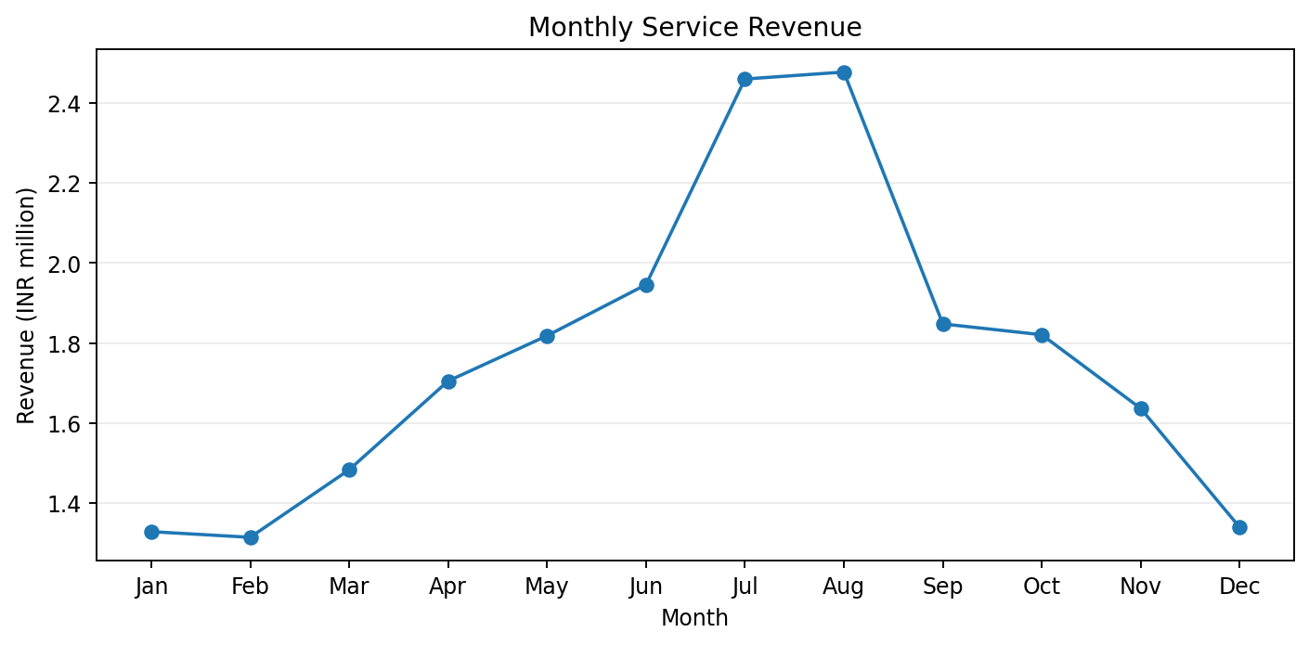
Figure 1. Monthly service revenue for 2025.
- August generated the highest revenue at INR 2,477,130, representing 11.7% of annual revenue.
- February generated the lowest revenue at INR 1,314,730.
- July had the lowest average rating at 4.39/5 and a repeat-visit rate of 9.3%.
- Revenue rose strongly from February through August and then declined toward December. This describes a seasonal pattern but does not identify its cause.

6.2 City performance
City | Jobs | Revenue (INR) | Avg bill | Avg TAT | Rating | Repeat %
Pune | 722 | 7,442,350 | 10,308 | 10.07 | 4.45 | 7.5%
Mumbai | 552 | 6,177,940 | 11,192 | 10.75 | 4.43 | 7.2%
Nagpur | 413 | 4,410,560 | 10,679 | 10.60 | 4.43 | 5.8%
Nashik | 313 | 3,147,570 | 10,056 | 9.58 | 4.51 | 5.1%
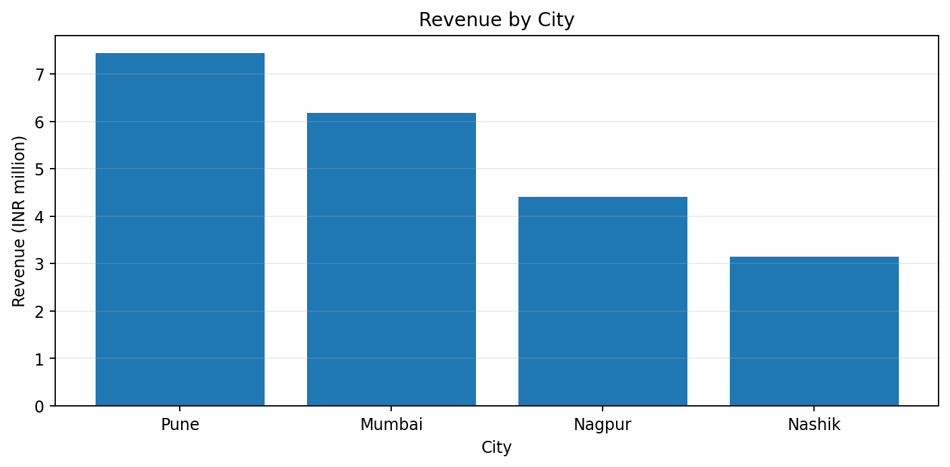
Figure 2. Total revenue by city.
- Pune completed 722 jobs and generated INR 7,442,350, equal to 35.1% of network revenue.
- Mumbai had the highest average bill among cities at INR 11,192, but its average turnaround time was also 10.75 hours.
- Nashik recorded the highest average rating at 4.51/5 and the shortest average turnaround time at 9.58 hours.
- Pune leads revenue primarily because it has the largest service volume. Comparing only revenue would hide differences in average bill, turnaround time and customer experience.

6.3 Top service centers
Service center | Jobs | Revenue | Avg bill | Avg TAT | Rating | Repeat %
Baner Auto Care | 244 | 2,801,520 | 11,482 | 10.60 | 4.42 | 7.0%
Wakad Service Hub | 233 | 2,440,210 | 10,473 | 10.40 | 4.47 | 6.9%
Wardha Road Auto Care | 219 | 2,233,520 | 10,199 | 10.20 | 4.43 | 4.1%
Andheri Service Hub | 194 | 2,227,910 | 11,484 | 11.19 | 4.41 | 9.3%
Hadapsar Workshop | 245 | 2,200,620 | 8,982 | 9.22 | 4.46 | 8.6%
Baner Auto Care generated the highest service-center revenue. Andheri Service Hub recorded a nearly equal average bill but a longer average turnaround time and a higher repeat-visit rate, making it a useful quality-review candidate.

6.4 Service-type performance
Service type | Jobs | Revenue | Avg bill | Avg TAT | Rating | Repeat %
Repair | 574 | 9,882,300 | 17,217 | 16.06 | 4.25 | 7.3%
Scheduled Maintenance | 806 | 5,097,070 | 6,324 | 5.43 | 4.63 | 5.0%
Emergency | 193 | 5,073,840 | 26,289 | 24.33 | 3.89 | 18.7%
Inspection | 292 | 867,370 | 2,970 | 3.98 | 4.66 | 3.1%
Recall | 135 | 257,840 | 1,910 | 8.35 | 4.57 | 5.2%
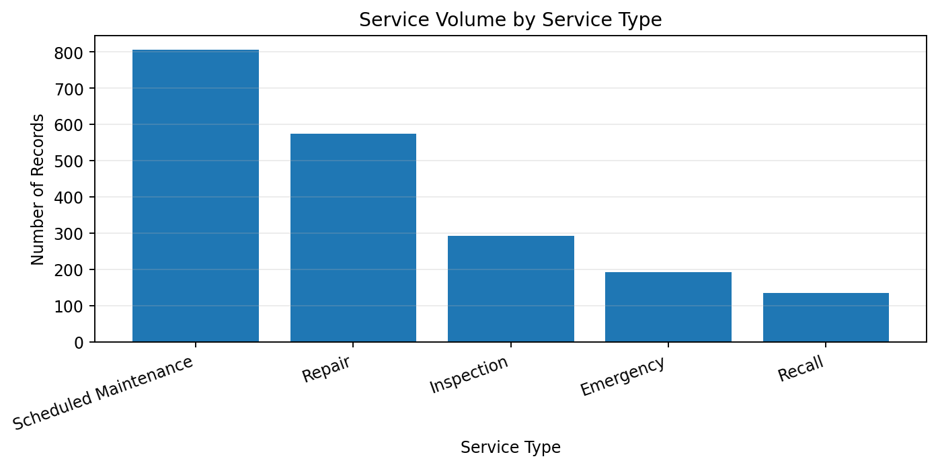
Figure 3. Service-job volume by service type.
- Repair generated the highest revenue: INR 9,882,300, or 46.7% of the annual total.
- Scheduled Maintenance had the highest volume with 806 jobs.
- Emergency jobs had the highest average bill at INR 26,289, the longest average turnaround time at 24.33 hours and the highest repeat-visit rate at 18.7%.
- The service mix explains why revenue and job count tell different stories: high-volume maintenance work has a lower average bill, while emergency work has low volume but high value and effort.

6.5 Complaint-category performance
Complaint | Jobs | Revenue | Avg TAT | Rating | Repeats | Repeat %
Engine | 303 | 5,398,510 | 17.65 | 4.16 | 35 | 11.6%
Electrical | 275 | 3,268,730 | 13.53 | 4.31 | 27 | 9.8%
Tyres/Suspension | 229 | 2,893,570 | 12.24 | 4.39 | 13 | 5.7%
Air Conditioning | 196 | 2,287,200 | 11.50 | 4.42 | 12 | 6.1%
Brakes | 309 | 3,525,340 | 10.57 | 4.45 | 19 | 6.1%
General Service | 688 | 3,805,070 | 4.63 | 4.66 | 28 | 4.1%
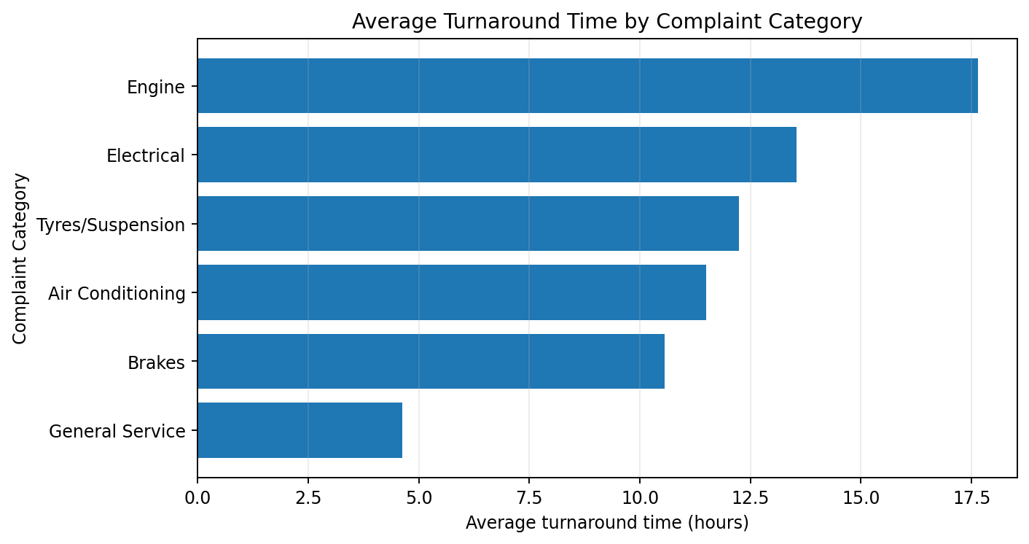
Figure 4. Average turnaround time by complaint category.
Primary quality signal
Engine complaints had the longest average turnaround time (17.65 hours) and the highest repeat-visit rate (11.6%, 35 jobs). Management should investigate diagnostics, parts availability, repair complexity and quality-control practices.

7. Customer Experience and Repeat Visits

7.1 Customer rating distribution
Rating group | Jobs | Share
Below 4.0 | 266 | 13.3%
4.0-4.49 | 612 | 30.6%
4.5-5.0 | 1122 | 56.1%
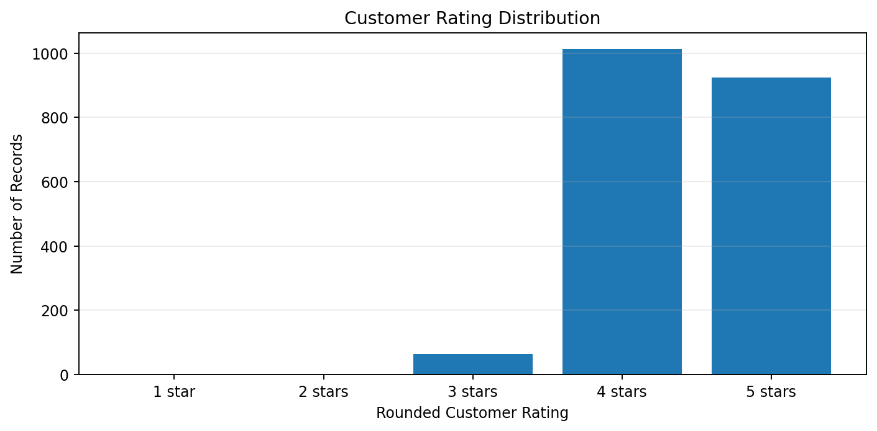
Figure 5. Distribution of customer ratings.
A total of 1,122 jobs (56.1%) received ratings from 4.5 to 5.0. However, 266 jobs were rated below 4.0 and should be examined by center, service type and complaint category.

7.2 Warranty-status comparison
Warranty status | Jobs | Revenue | Avg bill | Avg TAT | Rating | Repeats | Repeat %
Out of Warranty | 1155 | 16,606,700 | 14,378 | 10.76 | 4.45 | 67 | 5.8%
Under Warranty | 845 | 4,571,720 | 5,410 | 9.64 | 4.45 | 67 | 7.9%
- Out-of-warranty work generated 78.4% of total revenue and had a much higher average bill.
- Both groups had 67 repeat visits, but the under-warranty group had fewer total jobs. Therefore, its repeat-visit rate was higher at 7.9% versus 5.8%.
- The equal average rating of approximately 4.45 shows why a single satisfaction KPI can hide differences in repeat behavior and transaction value.

7.3 Long-turnaround cases
95th percentile threshold = 24.2 hours
Jobs at or above the threshold = 101 records
long_jobs = data[data["turnaround_hours"] >= data["turnaround_hours"].quantile(0.95)]

The top 5% threshold is 24.2 hours. Because several jobs share values near the cut-off, 101 records are at or above the threshold. These cases should be reviewed by service type, complaint category, center and parts availability.

8. Management Findings and Recommendations

8.1 Executive summary
- The network completed 2,000 service jobs and generated INR 21,178,420 in annual revenue.
- The average bill was INR 10,589, while the median was INR 7,605, showing a right-skewed bill distribution caused by high-value repairs and emergency jobs.
- August was the strongest revenue month, and Pune contributed 35.1% of annual revenue.
- Repair produced the most revenue, while Scheduled Maintenance produced the most jobs.
- Emergency work was the most operationally demanding service type, with a 24.33-hour average turnaround time and 18.7% repeat-visit rate.
- Engine complaints were the clearest complaint-level quality signal, with 17.65 average hours and 11.6% repeat visits.
- Overall customer satisfaction was strong at 4.45/5, but July, emergency work and certain centers require targeted review.
Recommended action | Implementation focus | Expected business value
1. Emergency-service review | Map the emergency workflow from intake to delivery; track diagnosis time, parts waiting time and rework separately. | Lower turnaround time and repeat visits.
2. Engine-complaint quality audit | Review engine diagnostic checklists, senior-technician allocation, parts availability and post-repair quality checks. | Reduce repeat visits and below-4.0 ratings.
3. Seasonal capacity planning | Use the July-August workload pattern for staffing, bay scheduling and fast-moving-parts planning. | Protect service quality during peak months.
4. Center benchmarking | Compare high-revenue centers with centers that have better turnaround and rating outcomes. | Share practices rather than rewarding revenue alone.
5. Repeat-visit dashboard | Track repeat visits weekly by center, technician, service type and complaint category. | Detect quality problems earlier.
Important interpretation rule
The report identifies where management should investigate. It does not prove that technician experience, parts availability or workload caused the observed results. Causal questions require additional variables and statistical testing.

9. Complete Python Solution
The following script loads the supplied CSV file, validates the data, calculates the main summaries and produces four charts. Place the CSV file in the same folder as the script before running it.
from pathlib import Path
import pandas as pd
import matplotlib.pyplot as plt
# 1. Load data
DATA_FILE = Path("automobile_service_descriptive_analytics_2000_records.csv")
if not DATA_FILE.exists():
raise FileNotFoundError(f"Dataset not found: {DATA_FILE.resolve()}")
data = pd.read_csv(DATA_FILE, parse_dates=["service_date"])
# 2. Validate data
print("Shape:", data.shape)
print("Missing values:", data.isna().sum().sum())
print("Duplicate rows:", data.duplicated().sum())
print("Duplicate service IDs:", data["service_id"].duplicated().sum())
print("Date range:", data["service_date"].min(), "to", data["service_date"].max())
# 3. Prepare fields
month_order = [
"Jan", "Feb", "Mar", "Apr", "May", "Jun",
"Jul", "Aug", "Sep", "Oct", "Nov", "Dec"
]
data["month"] = pd.Categorical(
data["month"], categories=month_order, ordered=True
)
data["repeat_flag"] = (data["repeat_visit_30d"] == "Yes").astype(int)
# 4. Network KPIs
total_jobs = len(data)
total_revenue = data["total_bill_inr"].sum()
average_bill = data["total_bill_inr"].mean()
median_bill = data["total_bill_inr"].median()
average_tat = data["turnaround_hours"].mean()
median_tat = data["turnaround_hours"].median()
average_rating = data["customer_rating"].mean()
repeat_visits = data["repeat_flag"].sum()
repeat_rate = data["repeat_flag"].mean() * 100
print("\nNETWORK KPIs")
print(f"Total jobs: {total_jobs:,}")
print(f"Total revenue: INR {total_revenue:,.0f}")
print(f"Average bill: INR {average_bill:,.2f}")
print(f"Median bill: INR {median_bill:,.2f}")
print(f"Average TAT: {average_tat:.2f} hours")
print(f"Median TAT: {median_tat:.2f} hours")
print(f"Average rating: {average_rating:.2f}/5")
print(f"Repeat visits: {repeat_visits} ({repeat_rate:.1f}%)")
# 5. Reusable summary function
def summarize(group_column):
return (
data.groupby(group_column, observed=True)
.agg(
jobs=("service_id", "count"),
revenue=("total_bill_inr", "sum"),
average_bill=("total_bill_inr", "mean"),
average_tat=("turnaround_hours", "mean"),
average_rating=("customer_rating", "mean"),
repeat_visits=("repeat_flag", "sum"),
repeat_rate=("repeat_flag", "mean")
)
.assign(repeat_rate=lambda x: x["repeat_rate"] * 100)
.reset_index()
)
monthly = summarize("month").sort_values("month")
city = summarize("city").sort_values("revenue", ascending=False)
service_type = summarize("service_type").sort_values("revenue", ascending=False)
complaint = summarize("complaint_category").sort_values("average_tat", ascending=False)
service_center = summarize("service_center").sort_values("revenue", ascending=False)
warranty = summarize("warranty_status").sort_values("revenue", ascending=False)
print("\nMONTHLY SUMMARY\n", monthly.round(2).to_string(index=False))
print("\nCITY SUMMARY\n", city.round(2).to_string(index=False))
print("\nSERVICE-TYPE SUMMARY\n", service_type.round(2).to_string(index=False))
print("\nCOMPLAINT SUMMARY\n", complaint.round(2).to_string(index=False))
print("\nTOP FIVE CENTERS\n", service_center.head(5).round(2).to_string(index=False))
print("\nWARRANTY SUMMARY\n", warranty.round(2).to_string(index=False))
# 6. Rating groups and long-turnaround records
data["rating_group"] = pd.cut(
data["customer_rating"],
bins=[0, 3.99, 4.49, 5.0],
labels=["Below 4.0", "4.0-4.49", "4.5-5.0"],
include_lowest=True
)
print("\nRATING GROUPS\n", data["rating_group"].value_counts().sort_index())
threshold_95 = data["turnaround_hours"].quantile(0.95)
long_jobs = data[data["turnaround_hours"] >= threshold_95]
print(f"\n95th percentile TAT: {threshold_95:.1f} hours")
print(f"Jobs at or above threshold: {len(long_jobs)}")
# 7. Charts
plt.figure(figsize=(10, 5))
plt.plot(monthly["month"].astype(str), monthly["revenue"], marker="o")
plt.title("Monthly Service Revenue")
plt.xlabel("Month")
plt.ylabel("Revenue (INR)")
plt.tight_layout()
plt.savefig("monthly_revenue.png", dpi=160)
plt.close()
plt.figure(figsize=(8, 5))
plt.bar(city["city"], city["revenue"])
plt.title("Revenue by City")
plt.xlabel("City")
plt.ylabel("Revenue (INR)")
plt.tight_layout()
plt.savefig("city_revenue.png", dpi=160)
plt.close()
volume = service_type.sort_values("jobs", ascending=False)
plt.figure(figsize=(10, 5))
plt.bar(volume["service_type"], volume["jobs"])
plt.title("Service Volume by Type")
plt.xlabel("Service type")
plt.ylabel("Completed jobs")
plt.xticks(rotation=20, ha="right")
plt.tight_layout()
plt.savefig("service_volume.png", dpi=160)
plt.close()
plt.figure(figsize=(10, 5))
plt.barh(complaint["complaint_category"], complaint["average_tat"])
plt.title("Average Turnaround Time by Complaint Category")
plt.xlabel("Average turnaround hours")
plt.tight_layout()
plt.savefig("complaint_tat.png", dpi=160)
plt.close()
# 8. Export summaries
with pd.ExcelWriter("descriptive_analytics_solution_output.xlsx") as writer:
monthly.to_excel(writer, sheet_name="Monthly", index=False)
city.to_excel(writer, sheet_name="City", index=False)
service_type.to_excel(writer, sheet_name="Service_Type", index=False)
complaint.to_excel(writer, sheet_name="Complaint", index=False)
service_center.to_excel(writer, sheet_name="Service_Center", index=False)
warranty.to_excel(writer, sheet_name="Warranty", index=False)
long_jobs.to_excel(writer, sheet_name="Long_TAT_Jobs", index=False)
print("\nAnalysis completed successfully.")

10. Trainer Discussion Guide and Assessment Rubric

10.1 Suggested discussion questions
- Why are the average and median bills different, and which one better describes a typical job?
- Why does Scheduled Maintenance lead job volume while Repair leads revenue?
- Should Pune automatically be called the best-performing city because it has the highest revenue?
- What additional data would be needed to explain long emergency turnaround times?
- How should management distinguish a repeat visit caused by unresolved repair from a new, unrelated problem?
- Which findings belong in an executive dashboard, and which belong in an operational drill-down?

10.2 Assessment rubric
Assessment area | Marks | Expected evidence
Data validation | 10 | Correct row/column counts, date range, duplicates and missing-value checks
KPI calculations | 20 | Correct totals, averages, medians, rating and repeat-rate calculation
Grouping and comparison | 25 | Accurate monthly, city, service-type and complaint summaries
Visual reporting | 15 | Charts are suitable, labelled and readable
Business interpretation | 20 | Findings are evidence-based and avoid unsupported causal claims
Recommendations | 10 | Actions are practical and clearly linked to findings

10.3 Quick answer key
Question | Answer
Total jobs | 2,000
Total revenue | INR 21,178,420
Average bill | INR 10,589.21
Median bill | INR 7,605
Average turnaround | 10.29 hours
Average rating | 4.45/5
Repeat-visit rate | 6.7%
Highest-revenue month | August
Highest-revenue city | Pune
Highest-revenue service type | Repair
Longest service type | Emergency
Highest complaint repeat rate | Engine
Lowest-rating month | July
95th percentile TAT threshold | 24.2 hours
Files used with this document
Use the supplied CSV or Excel workbook containing the 2,000 records. The workbook also includes a dashboard and data dictionary for demonstration.

End of Case Study and Detailed Solution

